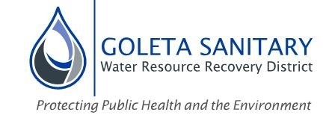
Mission
We protect public health and environment by responsible
wastewater collection, treatment and resource recovery to meet
present and future community needs.
Vision
To be recognized as the region's leader in water resource recovery
through innovation and excellence
Values
We value our Community-the People We serve and the Environment we protect by:
Acting with Integrity, we deliver on our commitments
Being Dependable, we can be counted on to do what needs to be done
Being Responsible, we do it in a responsible and cost-efficient manner
Being Safe, we do it in a safe manner at all times
Being Innovative, we are focused on the future
Did you know...
- The Goleta Sanitary District was formed in 1942 and is governed by a 5-member Board of Directors elected by-district every alternating 2 years.
- We serve approximately 80,000 people in the Goleta Valley.
- We provide wastewater treatment and disposal services to the City of Goleta, UCSB, Isla Vista, Santa Barbara Airport and adjacent unincorporated areas of the County of Santa Barbara.
- Our staff continually inspect, clean and maintain over 132 miles of underground pipes throughout the District.
- Our Water Resource Recovery Facility (WRRF) can treat up to 9.8 million gallon of wastewater and can produce up to 3 million gallons of recycled water every day.
- Our treatment process includes 3 stages: Primary (physical separation), Secondary (biological removal of organics) and Tertiary (carbon filtration) before any remaining pathogens are removed through chemical disinfection.
- We operate our facilities 24 hours a day 365 days a year.
- Treated wastewater that isn’t re-used for irrigation is purified then discharged in the ocean 1 mile offshore of Goleta Beach.
- Our State-Certified Laboratory staff perform over 600 separate water quality tests every month to ensure we meet all State and Federal requirements.
- Our annual operating budget for FY2021-22 is approximately $16.7M
- We have a total of 35 employees (full time equivalent)
- The District is funded in part by sewer service fees that are included on the property tax bill.
- The District’s sewer service fee for a single-family residence is $44.20 per month which is over 30% less that the County’s average sewer service fee.
- We recently received the District of Distinction – Platinum Level award from the California Special Districts Association for transparency, training and good governance practices for the second time!

Regional Water Resource Recovery Facility
- A regional facility that serves the entire Goleta Valley
- Designed to treat up to 9.8 million gallons of wastewater per day
- Includes a 3-step biological treatment process to produce an extremely
clean effluent that meets strict State and Federal requirements
- Produces biomethane that is collected and reused onsite for heating
purposes
- Produces high quality soil amendments for residential and commercial uses
- Allows for production of up to 3 million gallons of recycled water per day for
landscape irrigation uses.
- Operated around the clock by State-certified personnel
- Onsite power generators ensure continued operation during power outages
- Designed to meet the long-range needs of the Goleta Valley.
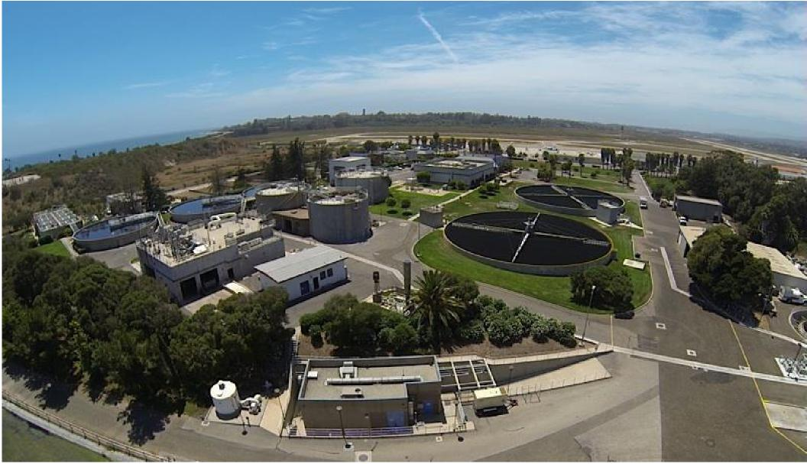
For more information visit us on Facebook, www.facebook.com/goletasanitarydistrict/
Or the web at www.goletasanitary.org

